CHAPTER I: Building a Web Server with ESP32 for IoT Projects
Introduction
In this chapter, we'll explore a series of mini-projects that focus on building web servers with the ESP32 microcontroller. These projects demonstrate how you can create interactive web interfaces to read sensor data and control devices. The overarching process across all three mini-projects is outlined below, followed by detailed descriptions of each individual project.
- General Process
The key elements for each mini-project involve:
1-1. Setting Up the ESP32
- The Wemos Lolin 32 board, a variant of the ESP32 microcontroller, serves as the backbone of these projects.
- Using the Arduino IDE, you write code that creates a web server. This code combines HTTP server logic with HTML and CSS for building the web interface.
1-2. Connecting Sensors and LEDs
- Depending on the mini-project, you connect sensors and LEDs to the ESP32 to interact with physical components through the web server.
- You implement functions within the code to read sensor data, control LEDs, and send/receive HTTP requests.
1-3. Creating the Web Server
- The ESP32 runs as a web server, generating an IP address accessible from any browser on the same local network.
- The web interface is designed with HTML and CSS, providing a user-friendly way to interact with the connected hardware.
- The code handles HTTP requests, returning a custom-built web page as a response.
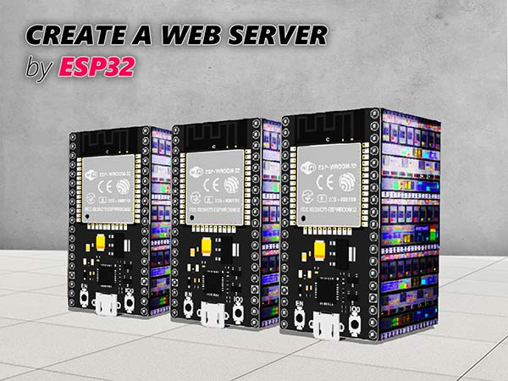
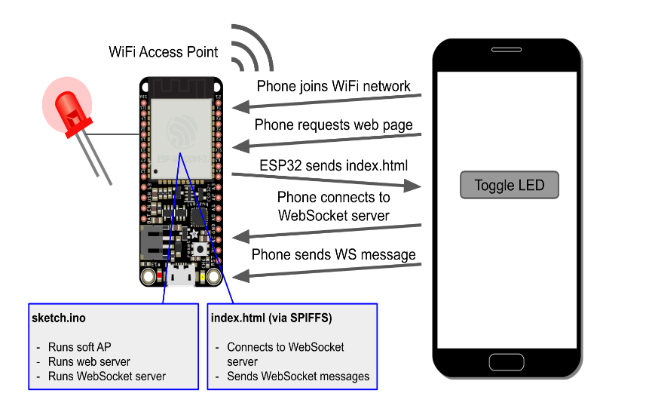
1-4. Accessing the Web Server
Figure 2 : ESP32 client-server interaction
Figure 1: ESP32 as a web server

- By entering the ESP32's IP address into a browser, you send a request to the web server.
- The ESP32 responds with a web page where you can interact with sensors and LEDs, depending on the mini-project.
- The code gives control over specific hardware components through user interface elements like buttons, sliders, and color wheels.
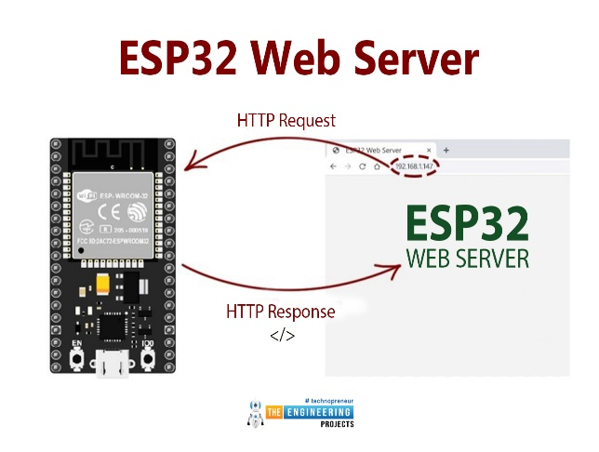
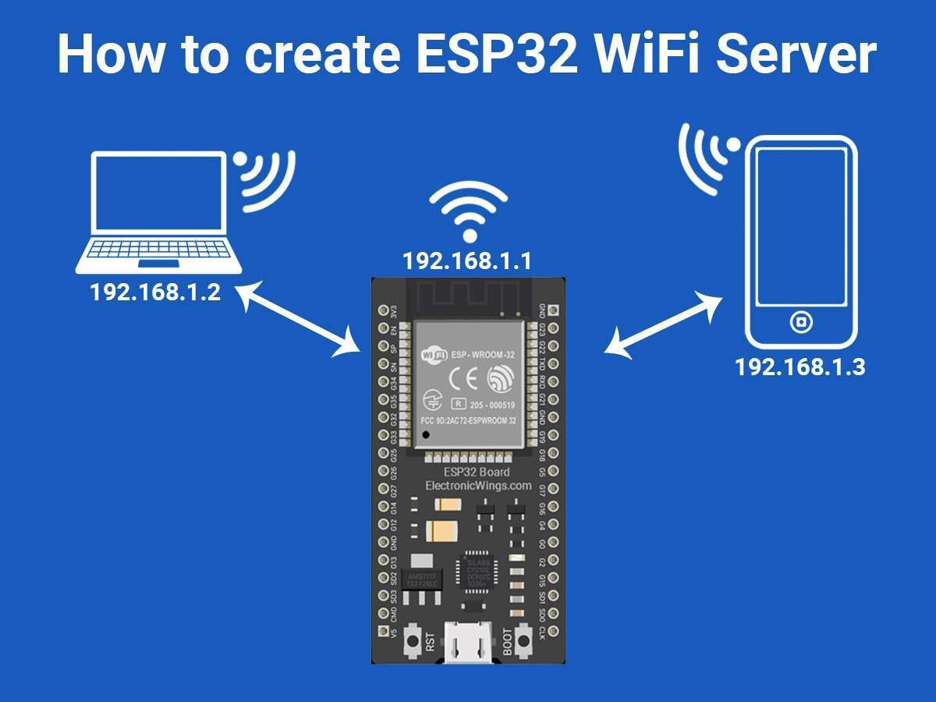
Figure 3: Request-Response interaction with ESP32 Web Server
However, there's an inherent limitation to this setup. The ESP32 web server is only accessible if the device and the ESP32 are on the same local network. If they are not connected to the same router, the web server is inaccessible. This constraint will be addressed in Chapter 2, where we discuss using Firebase as a cloud service to enable remote access to data and control devices from anywhere in the world.
2- Mini-Project 1: Displaying Temperature on a Web Page
In the first mini-project, the goal is to read temperature data using a DHT11 sensor and display it on a web page through the ESP32 web server. Here's how this is accomplished:
2-1.Setting Up the Sensor
- The DHT11 sensor is connected to the ESP32, allowing it to read temperature data.
- The code in Arduino IDE is written to capture temperature data from the sensor and convert it into a format suitable for displaying on a web page.
2-2.Creating the Web Interface
- The HTML and CSS code in Arduino IDE defines the layout and styling of the web page.
- The ESP32 acts as a web server, listening for HTTP requests at its assigned IP address.
2-3.Accessing the Web Page
- By entering the IP address into a browser, you send a request to the ESP32 web server.
- The ESP32 responds with a web page that displays the current temperature data.
This project demonstrates a simple use of the ESP32 as a web server, with the capability to read sensor data and present it on a web interface.
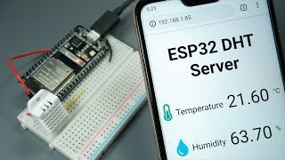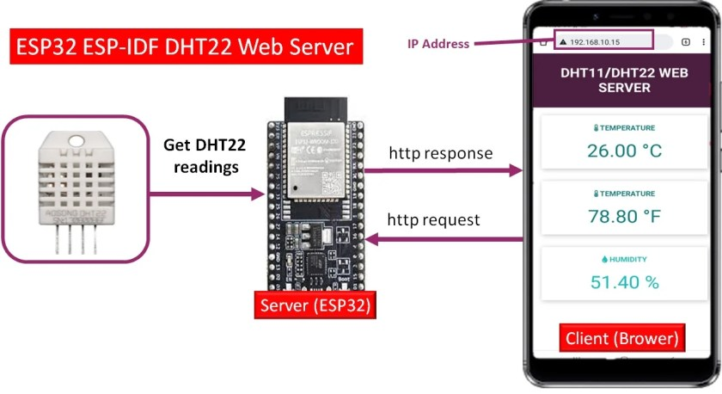
Figure 4: Displaying temperature and humidity on a Webpage via ESP32 Web server

3- Mini-Project 2: Controlling LEDs with a Web Page
The second mini-project focuses on controlling two LEDs through a web interface. The ESP32 still acts as a web server, but instead of displaying data, it now allows users to control hardware components.
3-1. Setting Up the LEDs
- Two LEDs are connected to the ESP32, each with an associated GPIO pin for control.
- The Arduino IDE code defines functions to activate and deactivate each LED based on user input from the web interface.
3-2 .Creating the Web Interface
- The HTML code provides a simple interface with two buttons—one for each LED.
- When the user clicks a button, an HTTP request is sent to the ESP32, which responds by turning the corresponding LED on or off.
3-3. Accessing the Web Page
- As with the first mini-project, the IP address generated by the ESP32 is entered into a browser to send a request to the web server.
- The ESP32 responds with a web page containing buttons to control the LEDs.
This mini-project shows how the ESP32 can be used to control devices remotely through a web interface, providing a simple yet effective way to interact with hardware components from a browser.
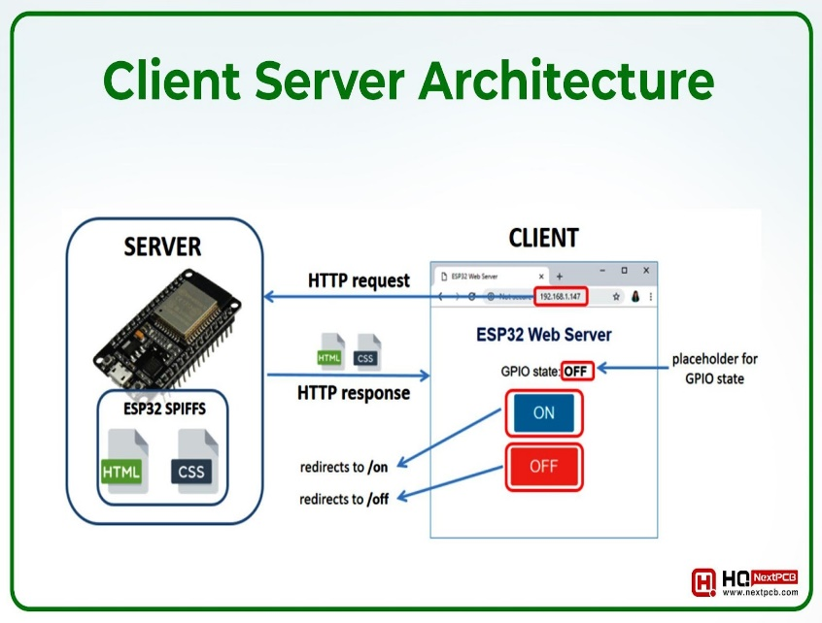
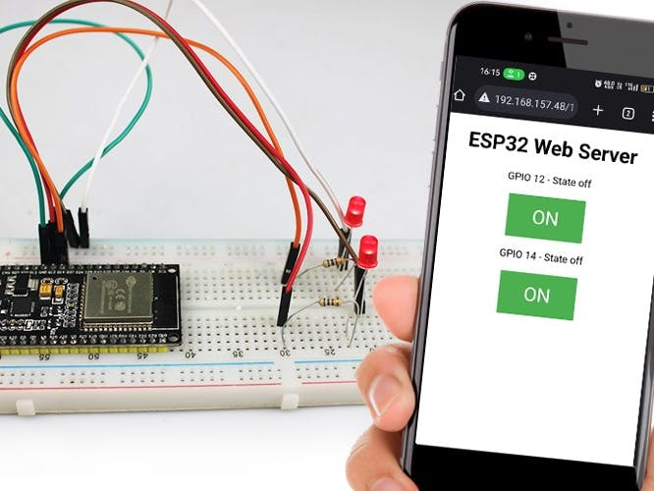
Figure 5: Controlling LEDS via ESP32 Webserver on a Webpage
4- Mini-Project 3: Controlling an RGB LED with a Web Interface
Mini-project 3 is all about controlling the color of an RGB LED through a web interface served by an ESP32. The project is an evolution of the previous two mini-projects, allowing more advanced control over the LED's color using both a manual intensity input and a color wheel.
4-1. Web Interface with Manual RGB Color Selection
Initially, you created a web interface that allows users to enter the intensity of red, green, and blue colors manually, ranging from 0 to 255. This setup follows the same process as the previous projects, with the following steps:
4-1-1. Setting Up the RGB LED
- The RGB LED is connected to the ESP32, with individual control over each color channel (red, green, and blue).
- The Arduino IDE code includes logic to adjust the color intensity based on user input from the web interface. This control is achieved through Pulse Width Modulation (PWM) to set the desired intensity for each color.
4-1-2. Creating the Web Interface
- The web interface uses HTML and CSS to create input fields for each color—red, green, and blue.
- Users enter values between 0 and 255 to set the intensity of each color channel, effectively determining the final color of the RGB LED.
- The ESP32 acts as a web server, handling HTTP requests to adjust the RGB LED based on user input.
4-1-3 .Accessing the Web Page
- The ESP32 generates an IP address, which is used to access the web page from a browser.
- The web page displays input fields for each color, allowing users to set the intensity manually.
- When users enter values and submit the form, an HTTP request is sent to the ESP32, which updates the RGB LED's color based on the provided values.
4-2. Web Interface with Color Wheel
To enhance the web interface, you created a second design that includes a color wheel, allowing users to select a color visually rather than entering values manually. This design provides a more user-friendly approach to color selection.

4-2-1 .Creating the Color Wheel Interface
- The color wheel is integrated into the web page using HTML, CSS, and potentially JavaScript for interactive functionality.
- Users can choose a color by interacting with the color wheel, which translates their selection into RGB values.
- The color wheel allows for a more intuitive color selection, simplifying the user experience.
4-2-2. Updating the Code for the Color Wheel
- The Arduino IDE code is modified to handle input from the color wheel, converting the selected color into RGB values.
- The ESP32 processes HTTP requests based on the color wheel's output, adjusting the RGB LED accordingly.
- This update retains the manual RGB input option, allowing users to choose between manual and color wheel-based color selection.
4-2-3 .Accessing the Web Page with the Color Wheel
- The updated web page, accessible through the ESP32's IP address, now includes the color wheel alongside the manual RGB input fields.
- Users can interact with the color wheel to choose a color, or they can still enter RGB values manually if they prefer.
- The ESP32 responds to HTTP requests to adjust the RGB LED's color according to the chosen values or color wheel selection.
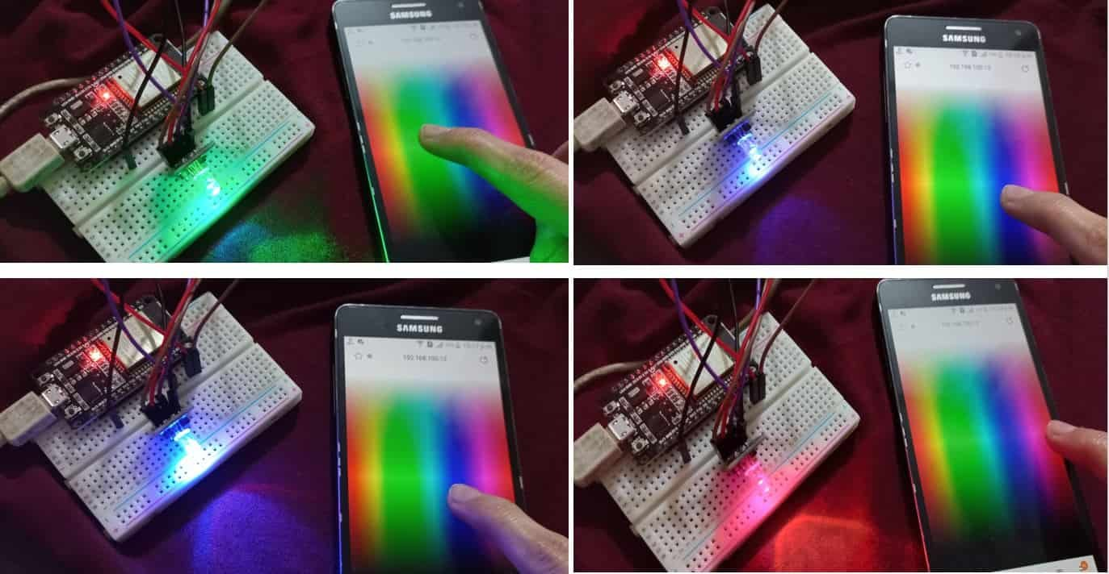
Figure 4: Controlling RGB colors through ESP32 Webserver on a Webpage

5- Limitations of the ESP32 Web Server
Overall, these three mini-projects demonstrate the process of building a web server with the ESP32, interacting with sensors, and controlling devices through web interfaces. While this setup is effective, it's limited to a local network. In the next chapter, we'll discuss using Firebase as a cloud service to overcome this limitation, allowing remote access to data and device control from any location.

